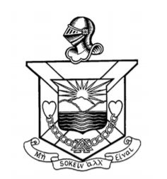 Delta Chi Association, Inc.
2023 Official Annual Proxy

KNOW ALL MEN BY THESE PRESENT THAT I, __________________________________,
residing at ______________________________________________________________
being a dues paying member of the Delta Chi Association, the Alumni Association of the Delta
Chi Chapter of DKE at Cornell, do hereby constitute and appoint Michael Furman,
a fellow DKE brother and member of the Delta Chi Association, as my proxy until such time as this
proxy is revoked to attend the Annual Meeting of said Association to be held virtually on Saturday, June
10 at 2 pm, or any continuation or adjournment thereof, with full power to vote and act for me in my
name, place and stead, in the same manner, to the extent and with the same effect that I might were I
personally present, giving to Michael Furman full power of substitution and revocation. I hereby revoke
any other proxy heretofore given by me. This proxy is also revoked if I attend the meeting in person.
Dated: ______________, 2023

___________________________________________
Signature
___________________________________________________________________________________
Please sign and return this proxy as soon as possible (not later than June 9) via postal mail to
Delta Chi Alumni Association Inc., PO Box 876, Ithaca, NY 14851-0876,
or via fax to (607) 533-9218, or by email to dwysocki@elevateims.com

